**TEAM MEMBERS:**

Parashara R 01FB15ECS202

Praveen C Naik 01FB15ECS213

Rahul Pillai 01FB15ECS224

**BRIEF SUMMARY OF APPROACH TAKEN:**

We used the glove word embeddings where each word is represented by a vector of 50 dimensions and these sequences of vectors are the inputs to the LSTM.

The model we have designed has embedding layer (which takes in as parameter an embedding matrix where it has a shape of (no_of_unique_words,50) and we have used the keras tokenizer to assign a token number to each unique word in all the training data) followed by a LSTM layer followed by a dense layer output layer of size 6(implements sigmoid in the last layer).

Since the output has only two labels “1” or “5” the output layer has a dimension of 6 as we have represented it as a one hot vector ie wither “010000” or “000001”.so our training and testing data also has all labels converted to their respective one hot vectors

We have also implemented precision ,recall as metrics of model evaluation.

**EXPERIMENTING WITH THE TUNING OF DIFFERENT HYPER PARAMETERS:**

**Exp1.CHANGING THE OPTIMIZER ONLY(WITH EACH OPTIMIZER HAVING ITS DEFAULT VALUES OF HYPER PARAMETER):**

**a.Table:**

|  |  |  |  |  |
| --- | --- | --- | --- | --- |
| **optimizer** | **Loss** | **accuracy** | **Recall** | **Precision** |
| rmsprop | 0.089555 | 0.9706666 | 0.912 | 0.912 |
| sgd | 0.395145 | 0.9613333 | 0.884 | 0.884 |
| adagrad | 0.109565 | 0.9513333 | 0.852 | 0.8553386 |
| adam | 0.119662 | 0.952 | 0.856 | 0.856 |
| adamax | 0.103506 | 0.9626666 | 0.888 | 0.888 |

**b.Graph:**

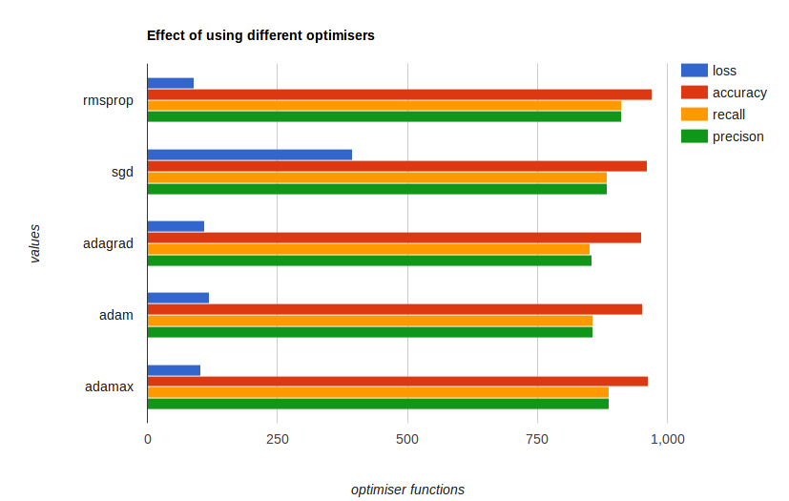

**Exp2.CHANGING THE NO OF HIDDEN UNITS IN THE LSTM LAYER ONLY:**

**a.Table:**

|  |  |  |  |  |
| --- | --- | --- | --- | --- |
| **#of_units** | **Loss** | **accuracy** | **Recall** | **Precision** |
| 16 | 0.142352 | 0.9573333 | 0.872 | 0.872 |
| 32 | 0.114545 | 0.9653333 | 0.896 | 0.896 |
| 64 | 0.092835 | 0.9706667 | 0.912 | 0.912 |
| 128 | 0.09427 | 0.9693334 | 0.908 | 0.908 |
| 256 | 0.103653 | 0.9626667 | 0.888 | 0.888 |

**b.Graph:**

**Exp3.CHANGING THE NO OF EPOCHS ONLY:**

**a.Table:**

|  |  |  |  |  |
| --- | --- | --- | --- | --- |
| **#of_epochs** | **Loss** | **accuracy** | **recall** | **Precision** |
| 4 | 0.106815 | 0.9626667 | 0.888 | 0.888 |
| 8 | 0.09877 | 0.9566666 | 0.872 | 0.8685203 |
| 16 | 0.086952 | 0.9693333 | 0.908 | 0.908 |

**b.Graph:**

**Exp4.CHANGING THE BATCH SIZE ONLY:**

**a.Table:**

|  |  |  |  |  |
| --- | --- | --- | --- | --- |
| **batch_size** | **Loss** | **accuracy** | **recall** | **Precision** |
| 32 | 0.077088 | 0.976 | 0.928 | 0.928 |
| 64 | 0.094156 | 0.968 | 0.904 | 0.904 |
| 128 | 0.094156 | 0.968 | 0.904 | 0.904 |

**b.Graph:**

**Exp5.CHANGING THE DROPOUT FACTOR ONLY:**

**a.Table:**

|  |  |  |  |  |
| --- | --- | --- | --- | --- |
| **droupout** | **Loss** | **accuracy** | **recall** | **Precision** |
| 0.2 | 0.102048 | 0.9693333 | 0.908 | 0.908 |
| 0.4 | 0.123301 | 0.9573333 | 0.872 | 0.872 |
| 0.5 | 0.134224 | 0.9546666 | 0.864 | 0.864 |
| 0.6 | 0.125594 | 0.9573333 | 0.872 | 0.872 |
| 0.8 | 0.105223 | 0.9693333 | 0.908 | 0.908 |

**b.Graph:**